**Q1-ANSIBLE-DOCUMENT**

**Why did this error occur?**

The package name python3 may not exist in the package manager's repository of server2

The server may be using a different Linux distribution (e.g., RHEL/CentOS vs Ubuntu), and package names differ

**How can you modify your playbook to handle this issue dynamically using Ansible Facts?**

Ansible Facts provide info about the system — like its OS family, distribution, version, etc. You can use this to dynamically install the right package based on the OS.

We’ll use:

-ansible_facts['os_family'] or ansible_facts['distribution'] to conditionally install packages.

**Create the project structure**



**Python.yml File:-**

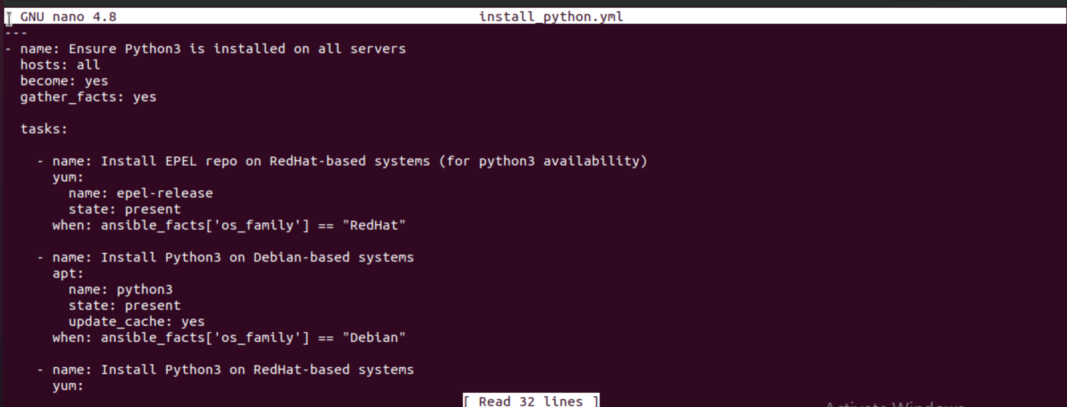

**After Running the playbook:**

